**Human Computer Interaction – A/B Testing Presentation**

**What is A/B Testing?**

**Description of method**

A/B testing is one of the easiest ways to increase conversion rates and learn more about your audience, but it is still underutilized by many otherwise very switched on, online marketing professionals. This is often because any form of testing is wrongly assumed to be very technical, time consuming and difficult to implement; however this is just not the case. When you consider what a key part of the sales equation conversion rate is and how valuable customer insight can be it is surprising that so many people ignore such a simple form of testing.

**Similar Approaches**

While the approach is identical to a between-subjects design, which is commonly used in a variety of research traditions, A/B testing is seen as a significant change in philosophy and business strategy in Silicon Valley.[2][3][4] A/B testing as a philosophy of web development brings the field into line with a broader movement toward evidence-based practice.

Between-Subjects design

Evidence-based practice

Multivariate testing or bucket testing

**What are A/B testing and conversion rates?**

A/B testing does pretty much what the name suggests, it tests a control, version A, against a different version, version B to measure which is the most successful based on the metric you are measuring.

In the online world A/B testing allows you to split traffic on your website so that visitors experience different web page content on version A and version B of a page while you monitor visitor actions to identify the version that yields the highest conversion rate. A conversion rate is the rate at which visitors perform a desired action on your site. By testing with live visitors on your site you learn from real users which experience they prefer.

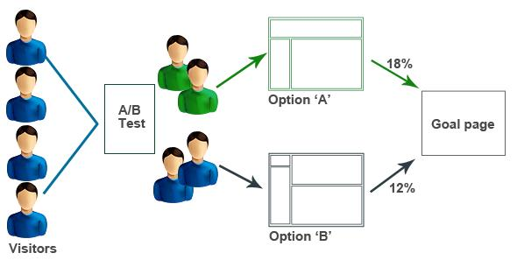

Usage Context

**When it should be used**

* Your understanding of how and when to implement the research method, and the resources that might be required.

**Nature of generated data**

* A description of what sort of data it can produce and how it can contribute to improving system design.

**Developer of the technique**

* An appreciation of the history and background of the research method.

In web development and marketing, A/B testing or split testing is an experimental approach to web design (especially user experience design), which aims to identify changes to web pages that increase or maximize an outcome of interest (e.g., click-through rate for a banner advertisement).

**Example of use**

* Case-studies of how the method has been used in practice.

<https://www.optimizely.com>

A/B Testing Create two (or more) different versions of your website and see which one performs better

For instance, on an e-commerce website the purchase funnel is typically a good candidate for A/B testing, as even marginal improvements in drop-off rates can represent a significant gain in sales. Significant improvements can be seen through testing elements like copy text, layouts, images and colors.[1] Multivariate testing or bucket testing is similar to A/B testing, but tests more than two different versions at the same time.

**Example 1: Invx**

invx.com: 5.6% improvement on home page

**Goal of the Page:** Users enter some text in the big text field.

**Version A -** 59.9% Conversion Rate

There is no placeholder text in the big text field and the submit button uses Twitter Bootstrap's default grey styling.

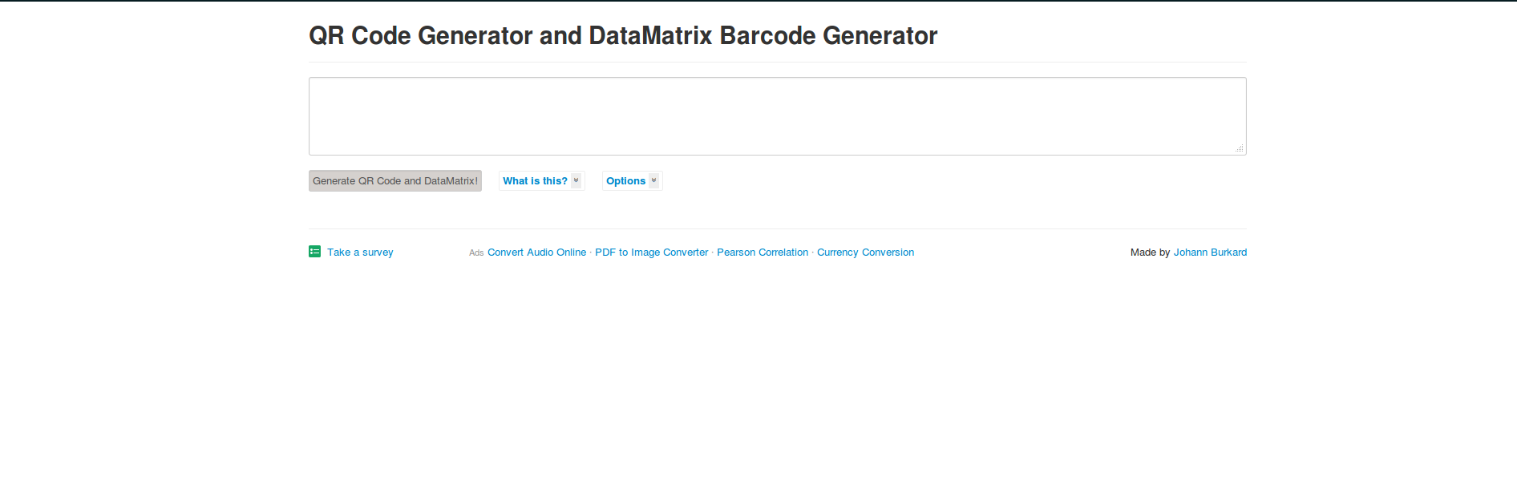

**Version B** - 63.2% Conversion Rate

"Enter your text" is used as placeholder text and the submit button uses the previously used white background with bold text.

Note that "Start typing" was also used as a placeholder text but performed worse than no text.

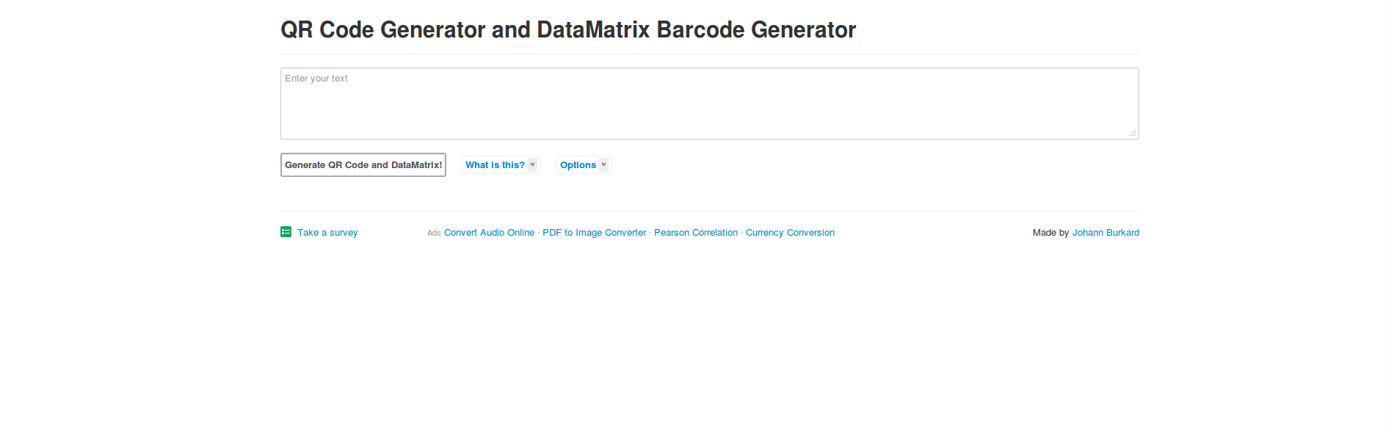

**Big Takeaway**

Use placeholders to communicate conversion steps in a space-efficient manner.

Other Test Highlights

Different font sizes, font faces and different page footer designs were tested in earlier tests but failed to make much of a difference.

**Tools Used:** Google Website Optimizer

**Live Page:** http://invx.com/

**Personal experience of the method**

You should also try out the method as a group and critique your own experiences in using it.

* Your own experiences in trying out the method.

N.b. Following your presentation, you’ll lead a short class discussion on the method and answer any questions from the class. Your team is responsible for documenting these discussions. You should arrange how you do this beforehand (for example, assigning someone as note-taker or audio-recording discussions).

**References**

**The Ultimate Guide To A/B Testing**

Paras Chopra. (2010). *The Ultimate Guide To A/B Testing.* Available: http://www.smashingmagazine.com/2010/06/24/the-ultimate-guide-to-a-b-testing/. Last accessed 4/02/2013.

**A/B testing**

Wikipedia. (2013). *A/B testing.* Available: [http://en.wikipedia.org/wiki/A/B_testing. Last accessed 4/02/2013](http://en.wikipedia.org/wiki/A/B_testing.%20Last%20accessed%204/02/2013).

**What is A/B Testing?**

Maxymiser. (2013). *What is A/B Testing.* Available: [http://www.maxymiser.com/resources/ab-testing. Last accessed 4/02/2013](http://www.maxymiser.com/resources/ab-testing.%20Last%20accessed%204/02/2013).

**A/B Test Examples**

**http://www.abtests.com/**